**How To Install Maple 18 in Window 10**

1. **Run the Maple 18 Installer Setup (“Maple18WindowsX64installer.exe”) and Click on “Next” “Button.**

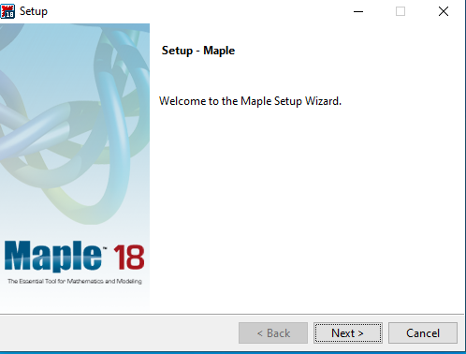

1. **Select “I accept the Licence agreement Option” and Click on “Next” Button.**

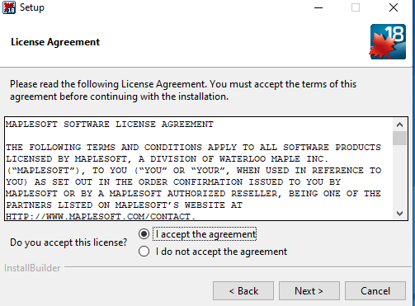

1. **Specify the Installation default folder and Click on “Next” button.**

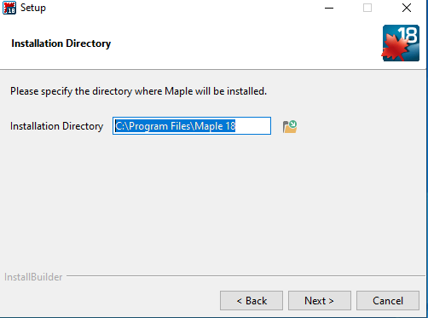

1. **Select “Yes” to create Shortcut on desktop and Click on “Next” Button.**

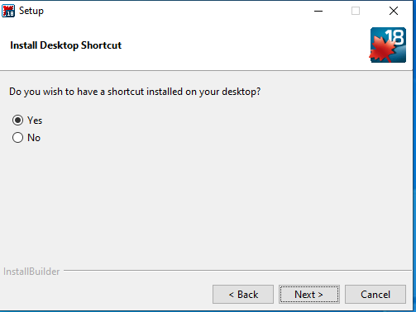

1. **Choose the Licensing type as “Network License” and Click “Next Button”.**

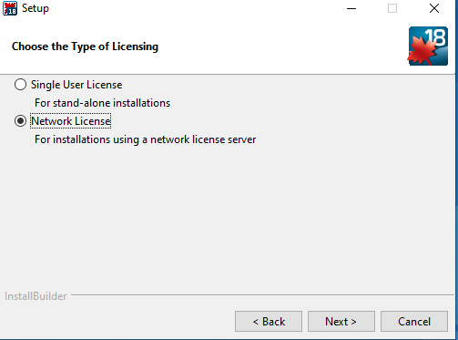

1. **Select “Single Server” and click “Next” Button.**

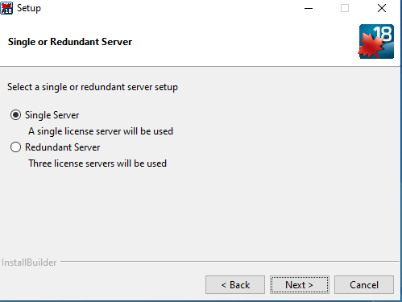

1. **Enter the License Server Detail and port Number (Licence Server is akash2.cc.iitk.ac.in and port number is 25000) and click on “Next button”.**

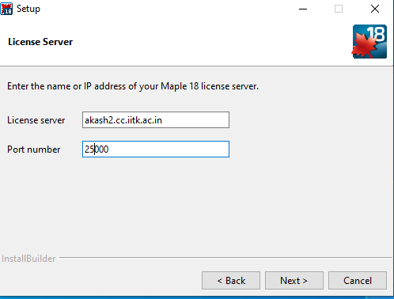

1. **Select options if Required and Click “Next” button.**

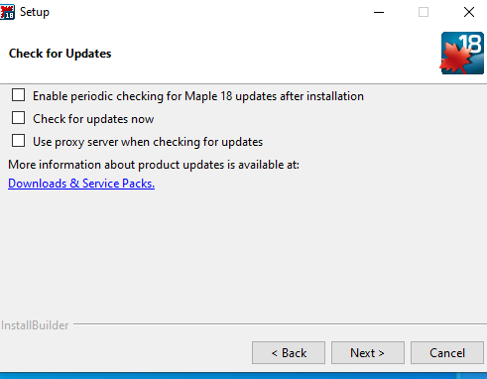

1. **Click on “Next” button to continue installation.**

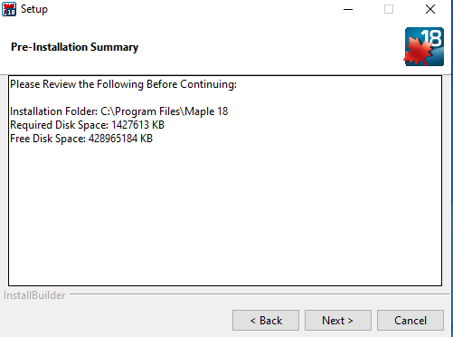

1. **Installation Process are Running. Wait several minutes.**

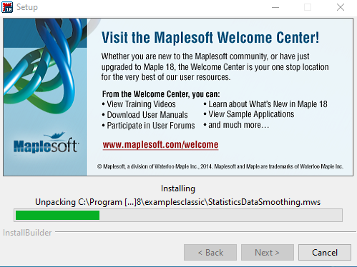

1. **Installation Completed then Click “Finish Button”.**

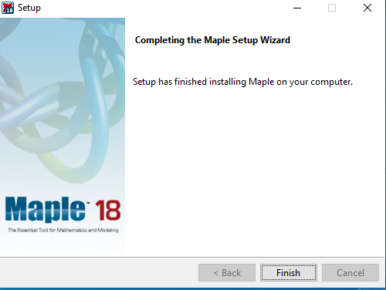

1. **Preview Of Maple Software as Below:**

